**group members**

**Submitted To**

[eprojects@aptech.ac.in](mailto:eprojects@aptech.ac.in)

**Project Instructor**

Sir Salman Masood

**Batch Code**

1612B1

**Semester**

HDSE 1

*Muhammad Farhab Ansari*

*Student 1005999*

*S.M.Muzammil Ali  
Student 1006322*

*M.Saad Ali*

*Student 100251*

*M.Umar Hasan Khan Hafiz*

*Student 1006687*



**Table of Contents**

*ACKNOWLEGDMENT* *1*

*PROJECT CERTIFICATION* *2*

*INTRODUCTION Sypnosis* *3*

*USER GUIDE* *4*

*REQUIRMENT SPECIFICATION* *5*

*DEVELOPER GUIDE* *6*

*SOFTWARE DESIGN & DFD DIAGRAMS* *7*

*Anaylsis and design* *8*

*PROJECT ERRORS SOLUTIONS* 9

*Screen Shot* 10

# ACKNOWLEDGEMENT

*We Are Thankful To Almighty, ALLAH That By His Grace We Have Been Successful. We Presenting On* ***Visual Studio*** *In Your Hands. We Have Tried Our Best To Take All Relevant Important Topics In Consideration So That This Project May Become Comprehensive.*

*This Is Our* ***3rd Semester HDSE-I E****-Project. We Have Tried Our Best & Struggled For A Better Outlook To Come. This Project Has Been Developed In* ***Visual Studio.*** *We Create This Application for Windows Store App And Project Name Is Employee Records Management Systems****.***

*We Earnestly Hope That This Project Will Provide All The Necessarily Information Required For The User To Fulfill Their Inspiration. However Suggestions For Improvement Of The Project Will Be Thankful Received & Acknowledge.*

# Project Certification

*This is to certify that,*

*Muhammad Farhab Ansari , M.Saad Ali , S.M.Muzammil Ali ,*

*Muhammad Umer Hasan Khan Hafiz*

*successfully Designed & Developed* **“*”***

*Date of Issue:*

***16-Jan-2015***

***Date of Submitting***

***16-Feb-2015***

*Authorized Signature:* ***Sir M.Salman Masood***

# Introduction & Synopsis

# Employee Record management system

**We Have Created Windows Store App Application Named Employee Records Management System.**

This Application Allow User To

1. Insert Data In Text File,
2. Delete File And Record,
3. Update or Modify Record,
4. Search Inserted Record By Employee Number
5. Display All Records
6. Count Records

All Data Will Be Stored In Text File And Should Be Available Whenever The Program Is Executed.

File Should Have Following Data Fields:

* Employee Number [Auto – Generated]
* First Name
* Last Name
* Age
* Basic Salary
* Department
* Date Of Joining
* Address City Phone Number

**USER GUIDE**

**EMPLOYEE RECORDS MANAGEMENT SYSTEM**

**What Employee Records Management System Do & How Many Pages It Has**

**Note:**

1. **If Project In Not Running Then Go to Visual Studio Then Go to Build Then Click on Clean Solution**

**2) Project saves Employee Records in System (C:\Users\Document\Employee) Folder**

**Please Use This Software in 1366x768 Resolutions**

**Loading Page**

1: Project First Page Is Loading Page Which Load Program After 3 Second.

**Login Page**

2: Project Second Page is Login Page It Require Username and Password to Enter in Project

Login User Name: Admin

Password Is: 123

**Main Page**

3: Project Main Page Include Insert Records Page , Delete Record Page , Update Record Page , & Search Record Page.

**Insert Record Page**

4: You Have to First Insert Employee Data In Insert Page Then Employee Number Will Automatically Generated and Save Your Employee Data In Text File in

**C:\Users\Document\Employee.** in Text File. Proper Validations is Maintained On All Data Fields.

**Update Record Page**

5: If You Want To Update Record Then You Have To go On Update Page Selected File From List Then Click On Find then Click On Update Button Your Employee Record Will Be Update

**Delete Record Page**

6: Delete Record Page Delete Your Selected Employee Record From The **C:\Users\Document\**Employee

**Search Record Page**

7: Search Record Page Search Your Employee Record If You Entered Employee Number.

Search Display Complete Record Of Employee. Records Is Properly Displayed In Grid & Proper Validations Should Be Maintained On All Data Fields. Key Field Should Be Employee Number; Hence No Two Records Can Have Same Employee Number

**REQUIRMENT :**

**HARDWARE REQUIRMENT :**

**Hardware**

* A minimum computer system that will help you access all the tools in the courses is a Pentium 166 or better
* 128 Megabytes of RAM or better
* Windows 2000 Server (or higher if possible)

**Software Requirements :**

**Software**

Use software as per your requirement

* Win-8/Visual Studio .net/C#/Notepad/SQL

**DEVELOPER GUIDE:**

|  |  |  |
| --- | --- | --- |
| **No.** | **Items** | ***Description*** |
| 1 | Operating System | Window 8 or 8.1 Only |
| 2 | Main processor | Minimum 1.66 Dual Core |
| 3 | Ram (Memory) | Minimum 1 GB |
| 4 | Screen Resolution | 1366x768 |
| 5 | Software | Visual Studio 2012 Or 2013 |

**System Requirement:**

Software Design :

LOGIN PAGE

Login Page Give Access User to Main Page of Project ID: Admin & Password Is: 123

MAIN PAGE

INSERT PAGE

DELETE PAGE

DFD DIAGRAM :

LOGIN PAGE

Login Page Give Access User to Main Page of Project ID: Admin & Password Is: 123

MAIN PAGE

Main Page Provide You Access to Insert Page to Add Record, Update Page to Update Added Record, Delete Page to Delete Page & Search Page to Search Added Records

Project Analysis

Delete Page Delete Previous Record

Search Record Search Your Entered Record

Y

Update Page Update Added Previously Added Record

INSERT PAGE INSERT DATA IN TEXT FILE

DELETE PAGE

INSERT PAGE

1. Analysis-18 Hrs.
2. Design – 22 Hrs.
3. Development –20Hrs
4. Testing – 12 Hrs.
5. Documentation -11 hrs.

|  |  |  |  |  |
| --- | --- | --- | --- | --- |
| Analysis | Design | Development | Testing | Documentation |

|  |  |  |  |  |  |  |  |  |  |  |  |  |  |  |  |  |  |  |  |  |  |  |  |  |  |  |  |  |  |
| --- | --- | --- | --- | --- | --- | --- | --- | --- | --- | --- | --- | --- | --- | --- | --- | --- | --- | --- | --- | --- | --- | --- | --- | --- | --- | --- | --- | --- | --- |
| 1 | 2 | 3 | 4 | 5 | 6 | 7 | 8 | 9 | 10 | 11 | 12 | 13 | 14 | 15 | 16 | 17 | 18 | 19 | 20 | 21 | 22 | 23 | 24 | 25 | 26 | 27 | 28 | 29 | 30 |

# 

Task Sheet

|  |  |  |  |  |  |
| --- | --- | --- | --- | --- | --- |
| No. | Task | Actual Start Date | Actual Days | Team Mate Name | Status |
| 1. | Case Study | 16th Jan 2015 | 2 | Ali , Mubassir , Hamza | Completed |
| 2. | Software Designing | 18th Jan 2015 | 9 | Ali , Naveed | Completed |
| 3. | Project Interface Designing | 19th Jan 2015 | 8 | Ali , Naveed | Completed |
| 4. | Data Base & Project Pages Creation | 22th Jan 2015 | 3 | Ali , Mubassir | Completed |
| 5. | Testing/Publishing | 12h Feb 2015 | 6 | Hamza, Naveed | Completed |
| 6. | Documentation | 14th Feb 2015 | 2 | Ali , Mubassir | Completed |

IF PROJECT IS NOT RUNING

**IF Project is Not Running and Provide deployment error then Open Project then to go**

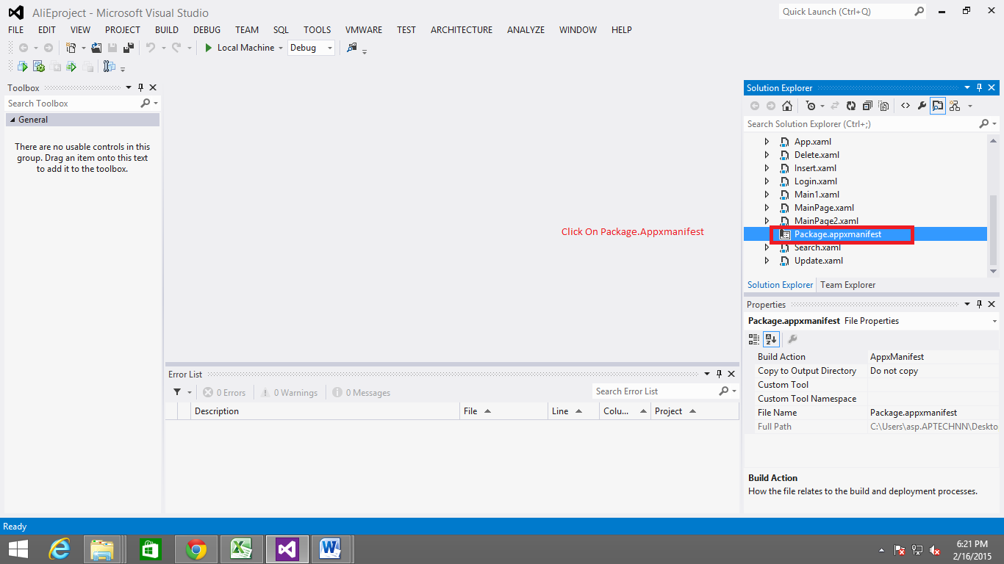

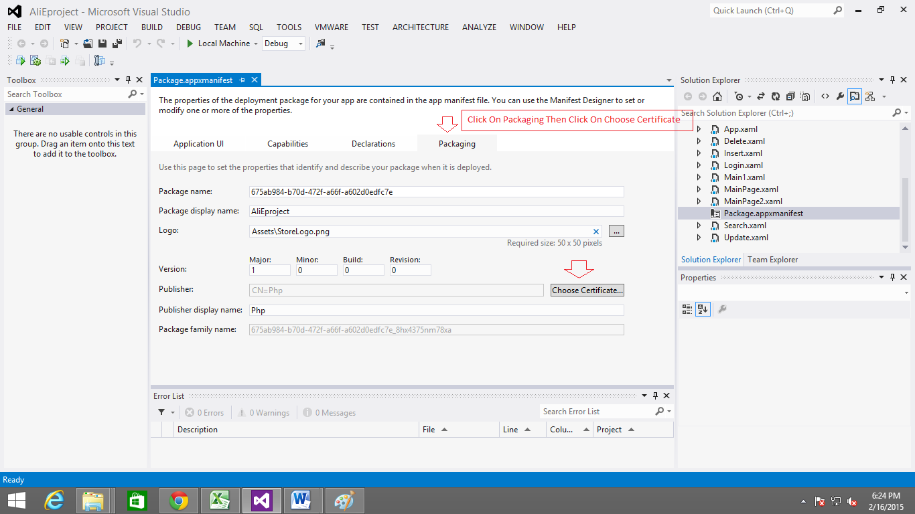

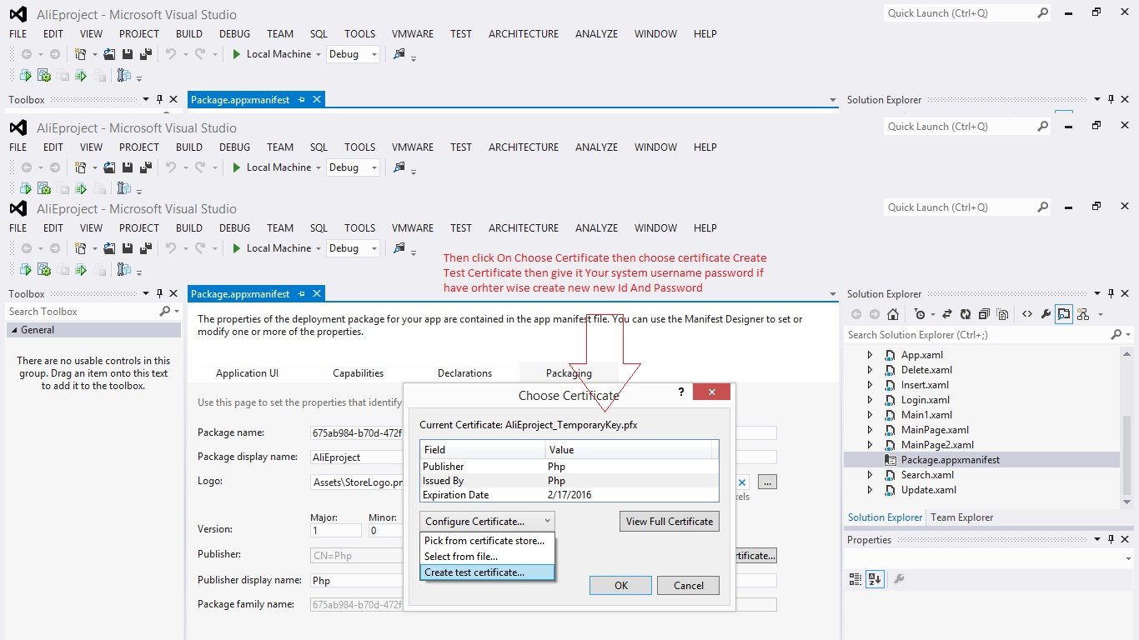

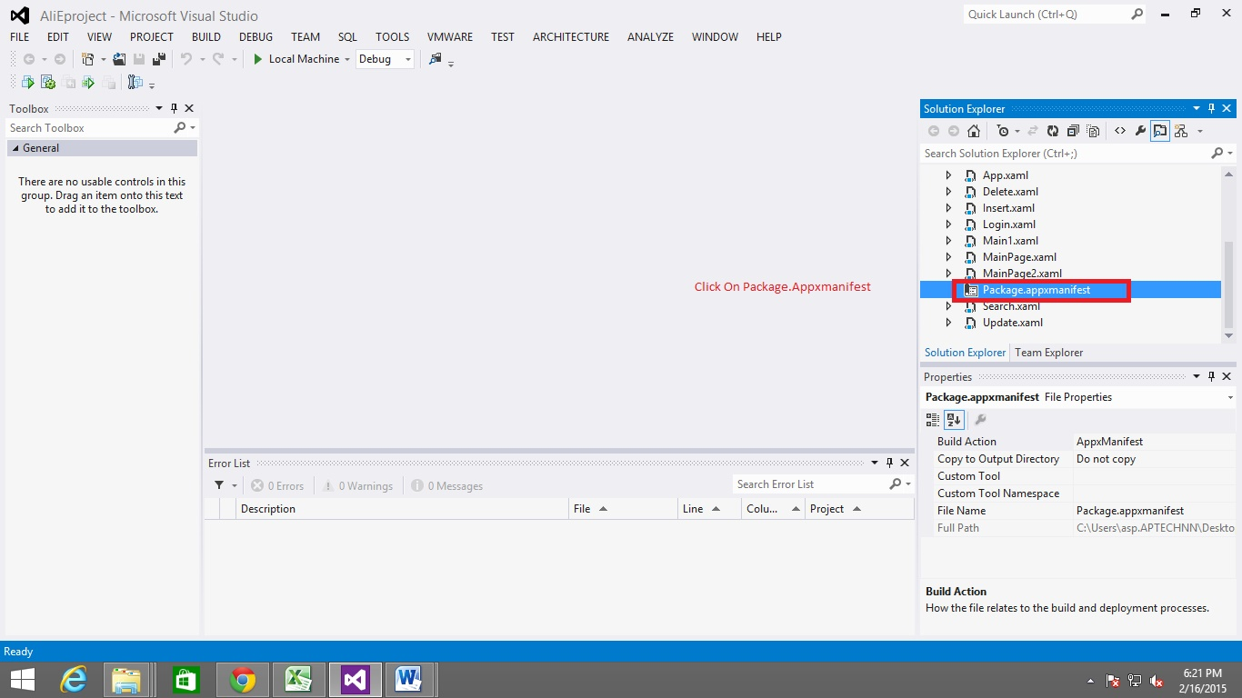

**SCREEN SHOT**

**Login Page**

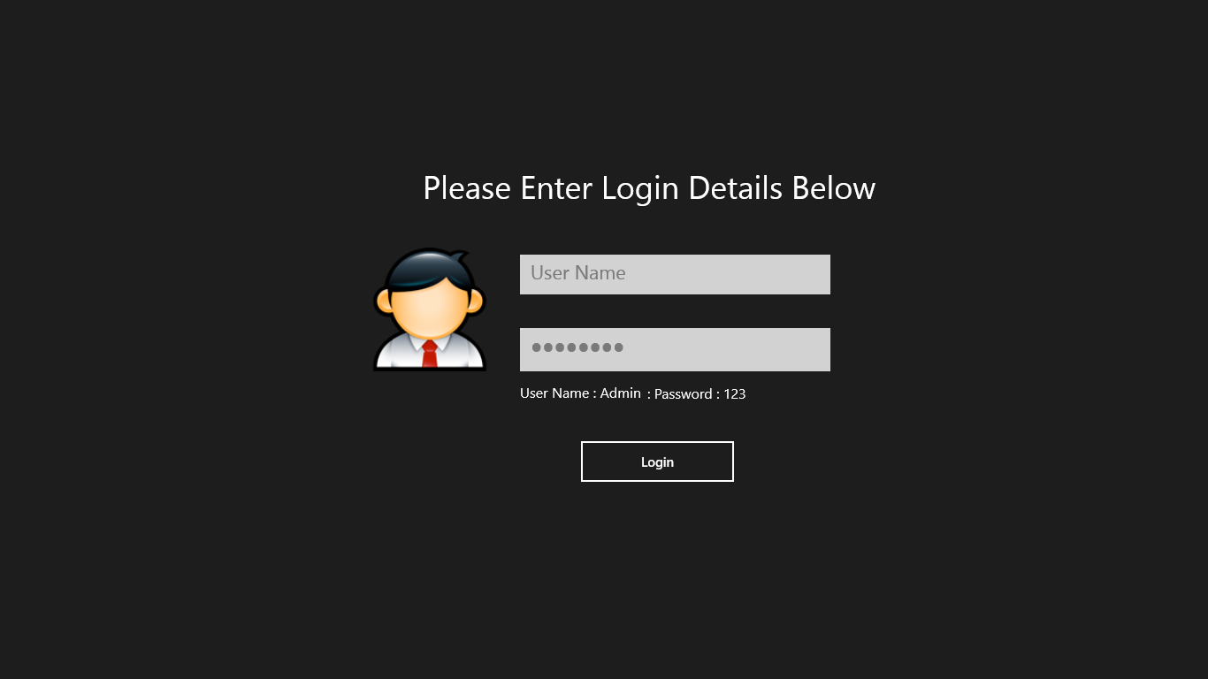

**MAIN PAGE OF SYSTEM**

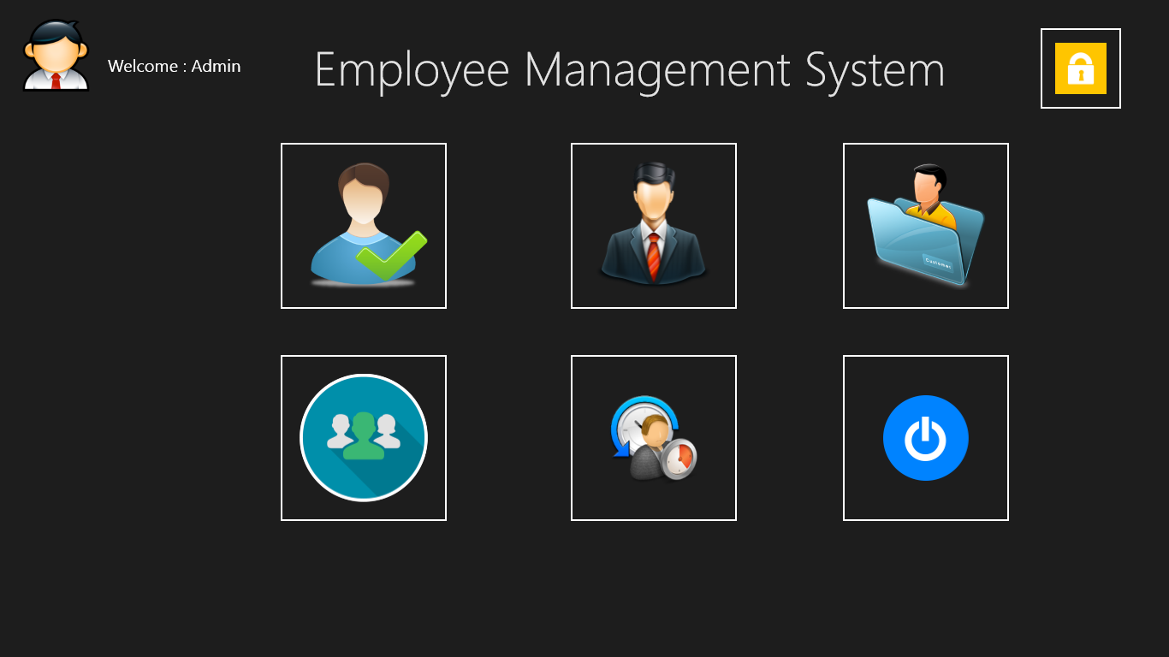

**INSERT EMPLOYEE RECORDS**

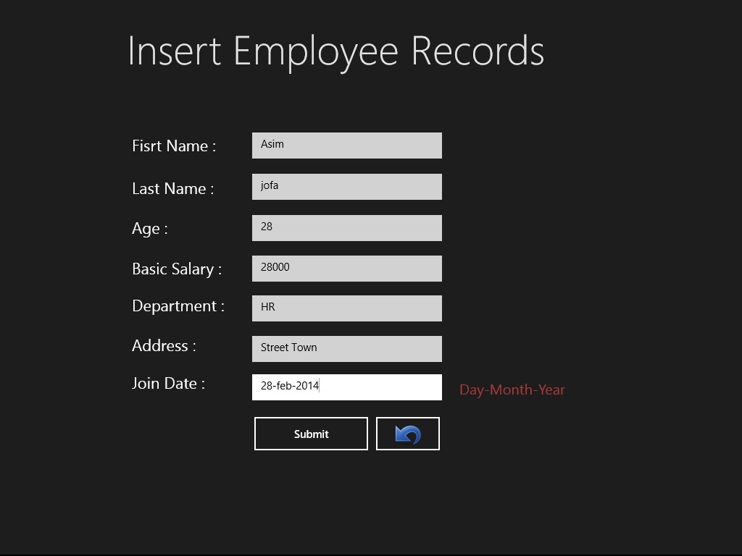

**UPDATE EMPLOYEE PAGE**

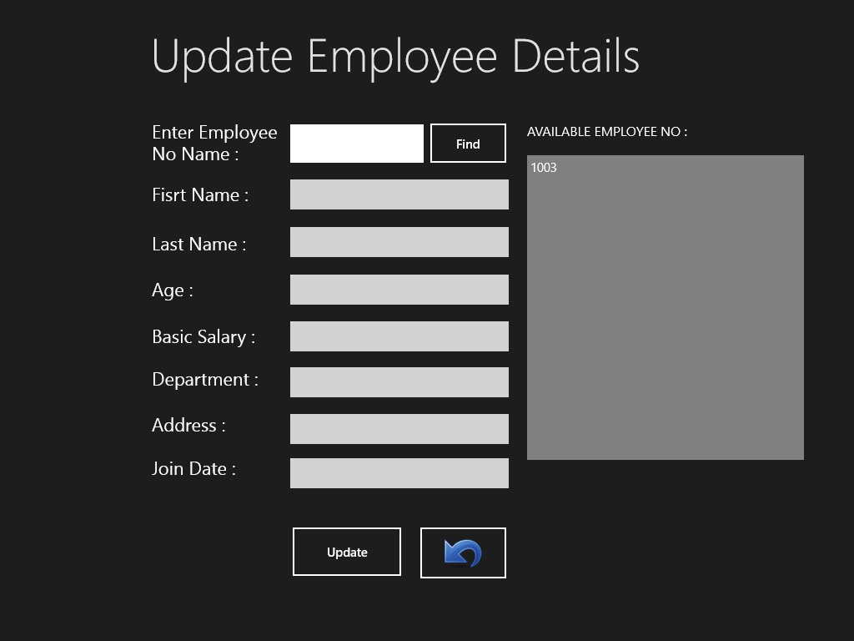

**SEACH EMPLOYEE PAGE**

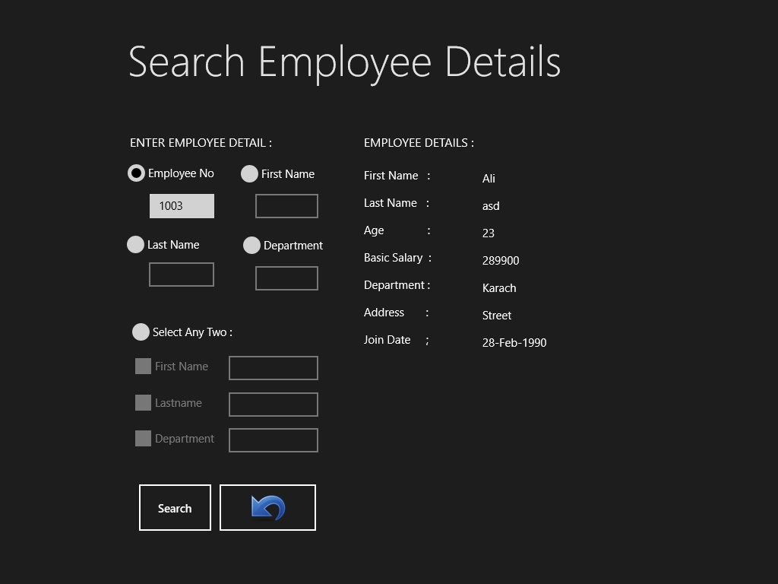

**DELETE EMYPLOYEE PAGE**

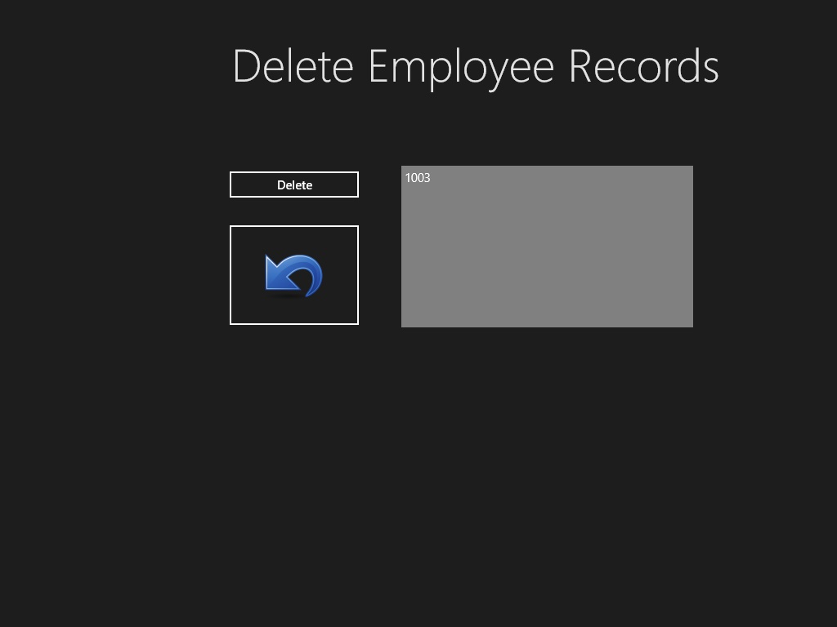

**SPLASH SCREEN**

